Station 1-Evaluate
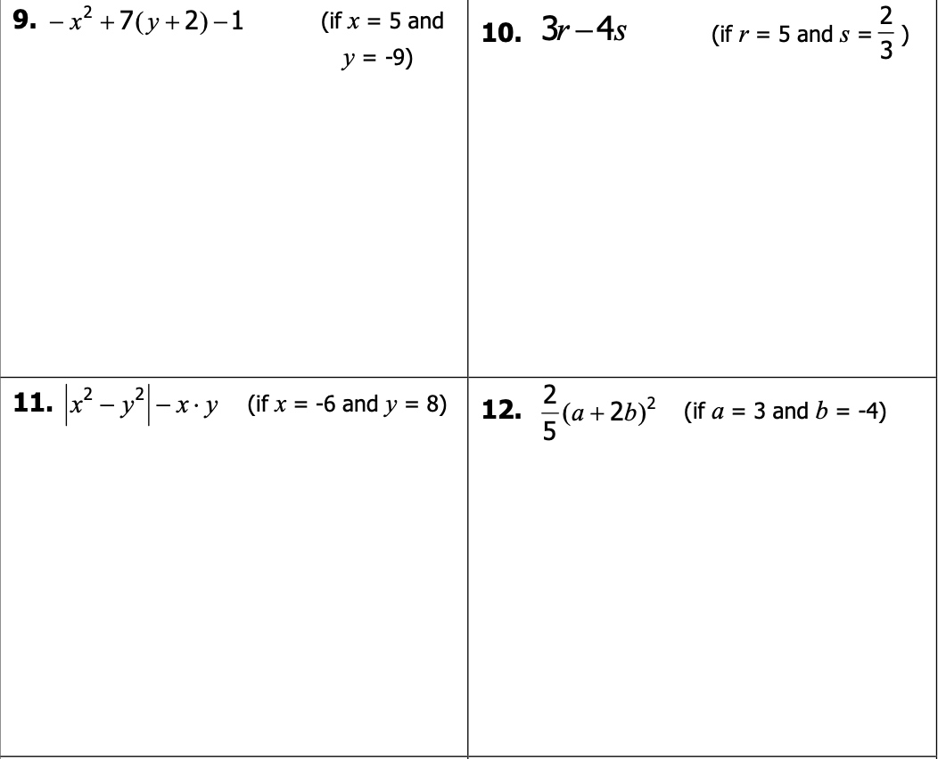

Station 2-PEMDAS
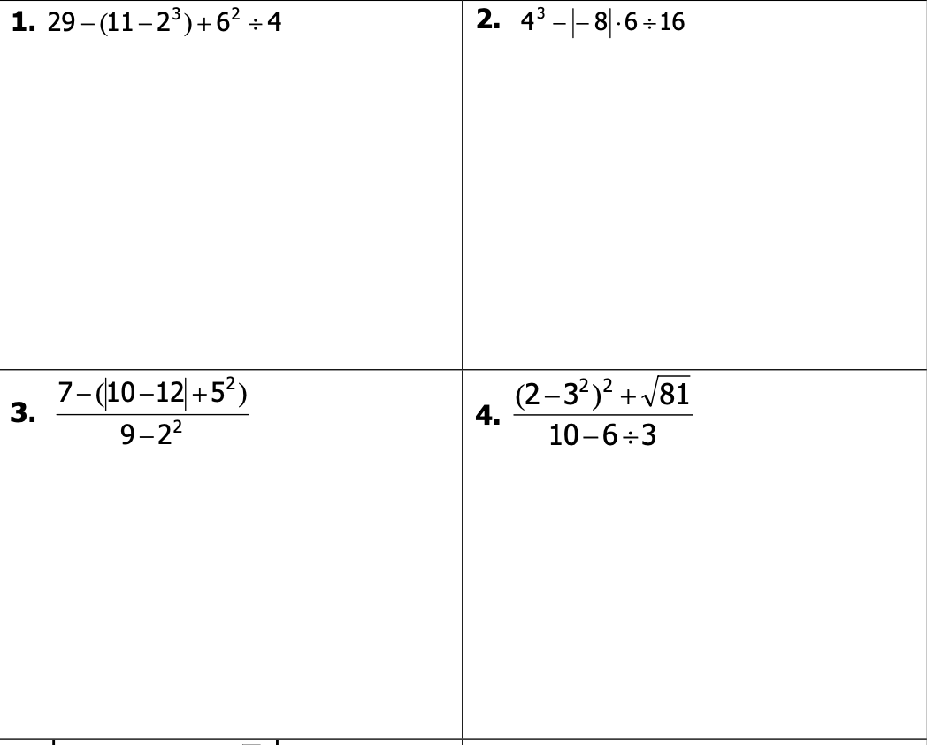

Station 3-Solve
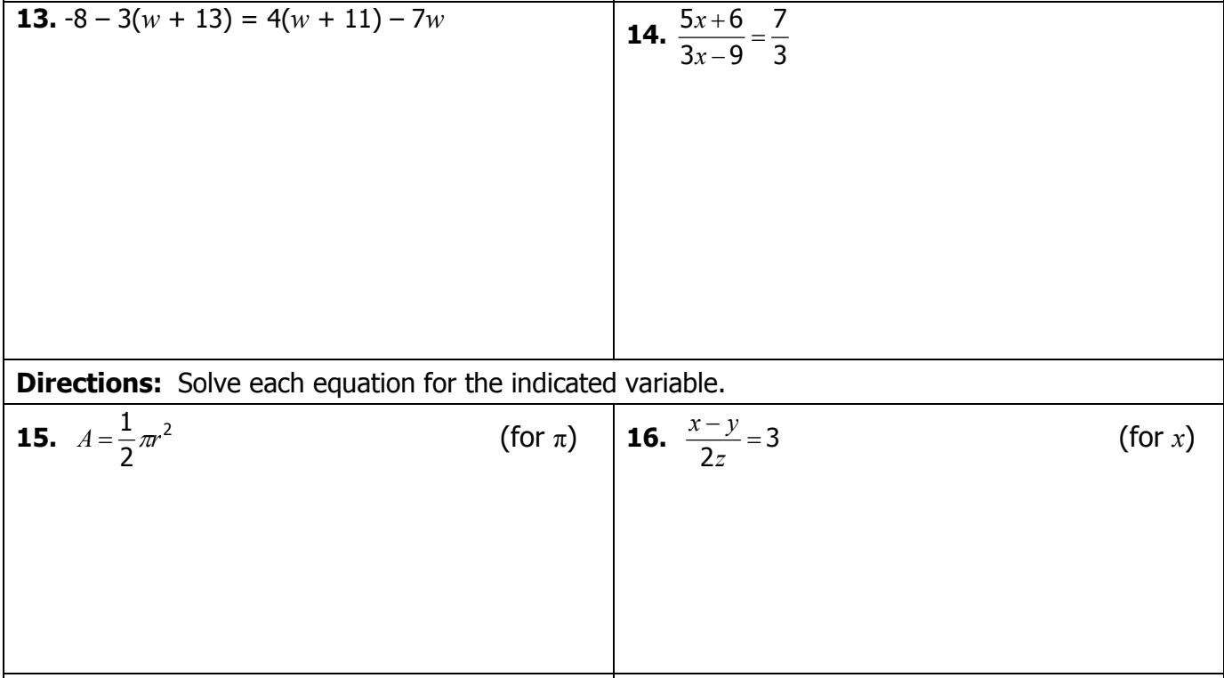

Station 4-Simplify
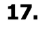
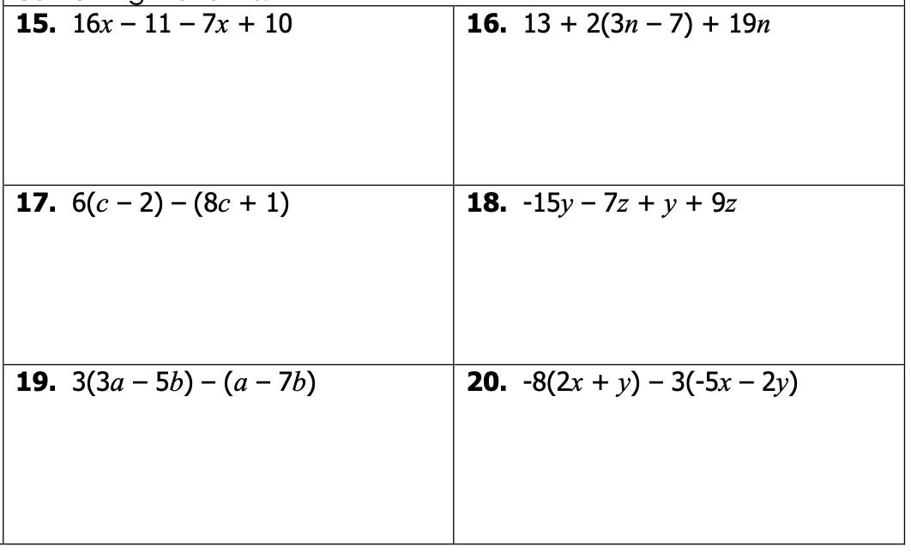

Station 5-Simplify

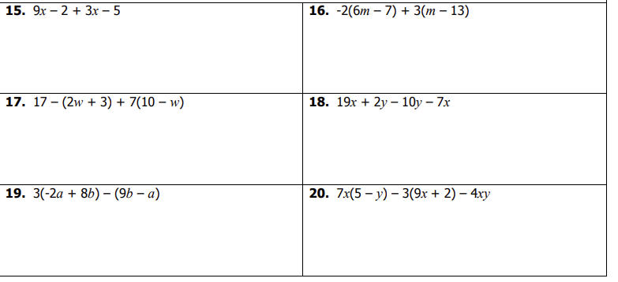
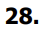

Station 6-Solving
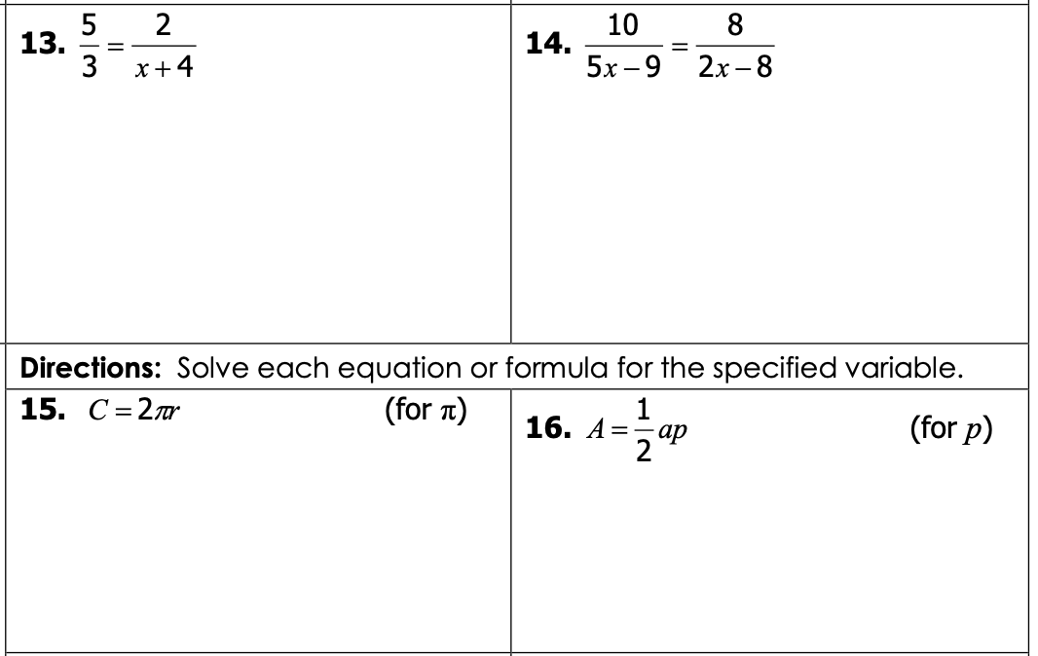

Station 7-Solve
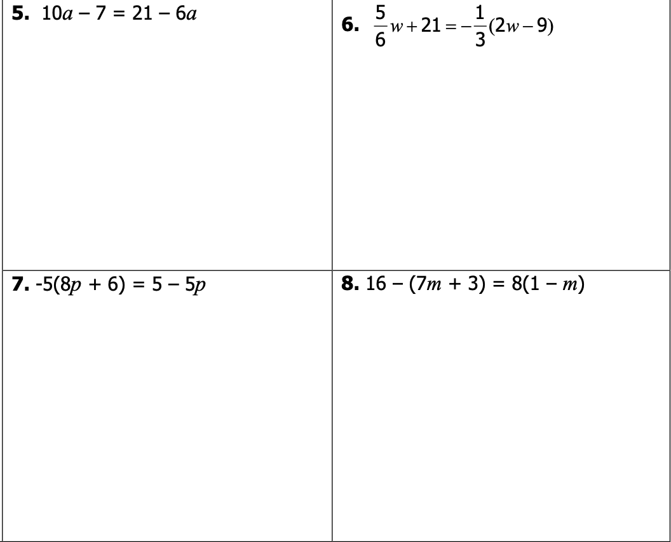

Station 8-Solve
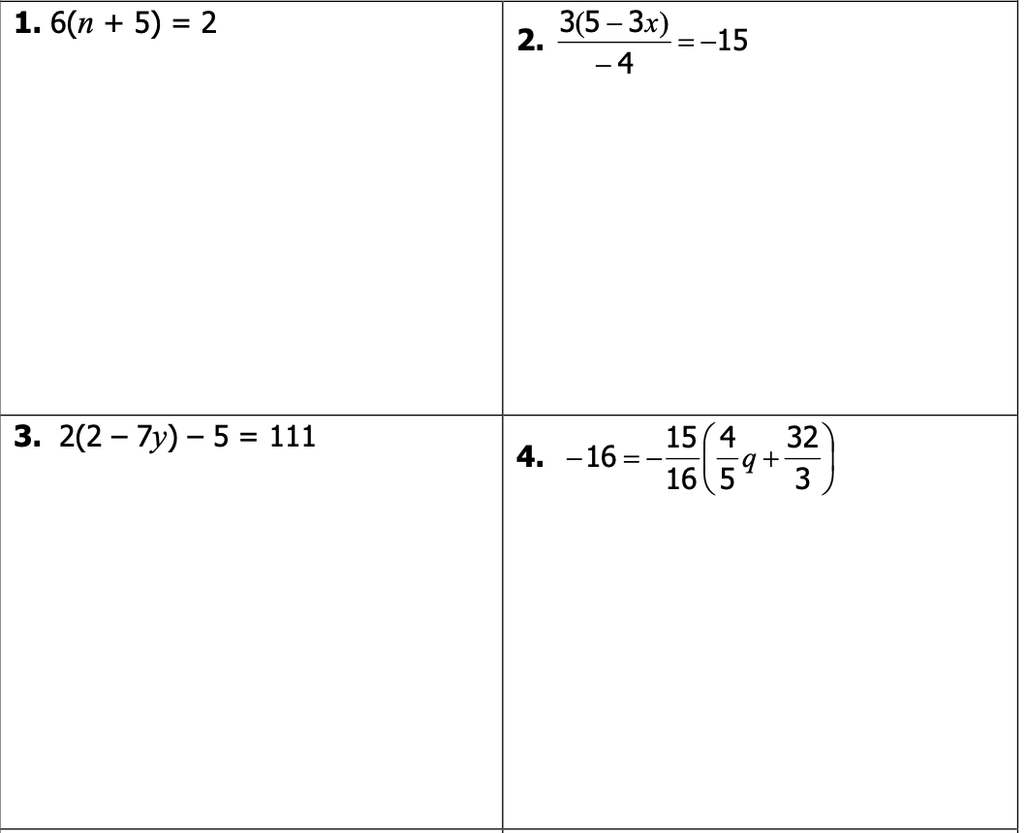

0.1 Stations Answer Sheet
Copy each problem down with the number and show your work.
You have to at least work the FIRST PROBLEM on each station.
The required numbers are listed below.

1. | 5.
9. | 13.
17. | 23.
28. | 34.

S#__P#__ | S#__P#__
S#__P#__ | S#__P#__
S#__P#__ | S#__P#__
S#__P#__ | S#__P#__
S#__P#__ | S#__P#__

S#__P#__ | S#__P#__
S#__P#__ | S#__P#__
S#__P#__ | S#__P#__
S#__P#__ | S#__P#__
S#__P#__ | S#__P#__

